Eating the rainbow: Fruit and vegetable education for Idaho families and preschoolers

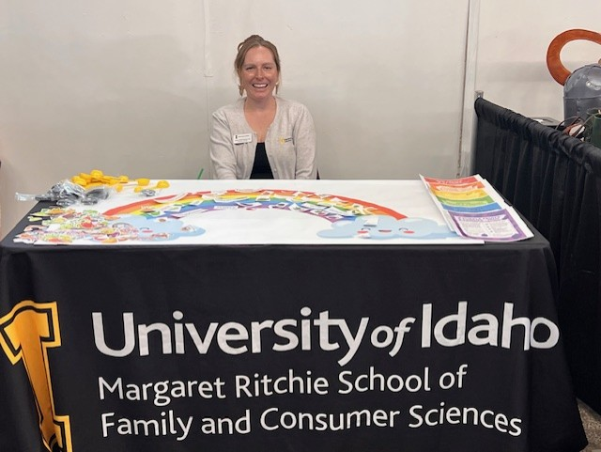

AT A GLANCE
Margaret Ritchie School of Family and Consumer Sciences
208-885-8727
875 Perimeter Drive MS 3183, Moscow ID 83844-3183
Adrianne Griebel-Thompson attends to the “Eating the Rainbow” booth at the 2025 Latah County Fair.
Consumption of 5 1/2 cup servings of fruits and vegetables per day is associated with improved health outcomes. However, nearly half of preschool children in the United States do not meet this goal.

The Situation
Fruit and vegetable consumption is associated with improved growth and development, immune function, weight management and gastrointestinal function in children. Furthermore, consumption of fruits and vegetables reduces risk of chronic diseases, like heart disease or type 2 diabetes. However, nearly half of preschool aged children to not consume the recommended 5 1/2 cup servings of fruits and vegetables per day. Practicing healthy habits, like eating enough fruit and vegetables, during childhood can lead to improved health throughout life.

Our Response
To address this situation, Griebel-Thompson has created the “Eating the Rainbow” program. The aim of this program is to promote healthy eating habits and fruit and vegetable knowledge among Idaho families and preschool children aged 3-5 years. This program involves two activities, a booth at the Latah County Fair and a lesson taught in preschool classes throughout the community.
The Latah County Fair attracts 25,000 attendees over four days. With this high attendance, the fair provides an opportunity for the Eating the Rainbow program to reach many Idahoans, some of whom might not have the time or interest to attend a more formal Extension class. The 2025 Eating the Fair Rainbow booth was designed as a matching game to attract children under the age of 5. A 3-foot by 4-foot rainbow provides the background for the game and children were encouraged to match fruits and vegetables cards to their corresponding color on the rainbow. To make the game more challenging for older children or adults, there are also cards with words that can be matched to the rainbow. For example, one of the cards was labeled “Red” in red ink and another is labeled with the word “Lycopene,” the compound that gives red plant foods their color, in red ink. Additional signage provided written information about the health benefits provided by different colors of fruits and vegetables. Rainbow and fruit and vegetable stickers were also handed out to those who engage with the booth. Griebel-Thompson had an age-appropriate conversation with each person who stopped at the booth to discuss fruit and vegetables preferences, serving sizes and the importance of eating a variety of colorful foods every day to improve health and prevent chronic disease.
The Eating the Rainbow program also has a classroom component. Griebel-Thompson brings a 3-foot by 4-foot rainbow poster to a preschool classroom and hangs it on the wall. The children and teachers then join her on the floor for circle time. Griebel-Thompson begins by introducing herself and teaching the children what nutrition means. She then reads the book “I Can Eat a Rainbow” by Olena Rose. When they finish reading, each child tells the class their favorite color and foods of that color. They then take an activity break to color fruit and vegetable coloring sheets and glue them on the rainbow. To conclude the lesson, the class has a short circle time where they discuss the colors of the rainbow, foods that are each color and why each color is good for their bodies. Before leaving, Griebel-Thompson serves the children a rainbow fruit salad and reads them the book, “My Magic Foods” by Becky Cummings. A week after the Eating the Rainbow class, the classroom administrator sends an email to the caregivers with a letter from Griebel-Thompson attached that discusses healthy eating habits that can be practiced at home.

Program Outcomes
In 2025 there were 586 Idahoans who visited the
Eating the Rainbow booth at the Latah County Fair. The feedback from most attendees was positive. They felt that fruit and vegetables are an important part of their diet and that everyone can benefit from eating more of them. This was a successful way to engage many Idahoans at one event and to spread the word about University of Idaho Extension.
For the preschool classroom, the caregivers were asked to fill out two short surveys. From this caregiver reported data we know that 60% of preschoolers consume less than five servings of fruits and vegetables per day; however, 90% of caregivers reported their child was “sometimes” or “very” willing to try new fruits and vegetables. We also learned pick eating (50%) was their biggest challenge. The most reported strategy (80%) to increase fruit and vegetable intake among preschoolers was role modeling by the caregiver. Finally, red and orange vegetables were the most consumed color of fruits and vegetables.
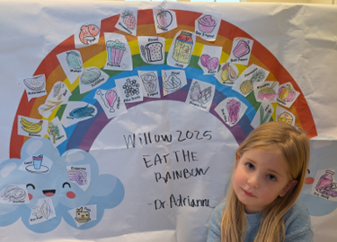
Adelia Thompson, 5, displays the rainbow poster created by her preschool class.

Feedback from the preschool teachers has been positive. They report the children enjoy having a visitor to the classroom and the content is age appropriate. It is also information that the teachers would like to cover in their classroom but do not have the time and resources. However, to address this, some classrooms have asked Griebel-Thompson to come again to cover new nutrition-related topics.

For more information
Adrianne K. Griebel-Thompson, Assistant Professor and Extension Specialist • Margaret Ritchie School of Family and Consumer Sciences • 208-885-8727 • adriannegt@uidaho.edu
68-25-athompson-fruit-vegetable • 12/25

