Interdisciplinary approach increases participants’ knowledge of grilling and food safety

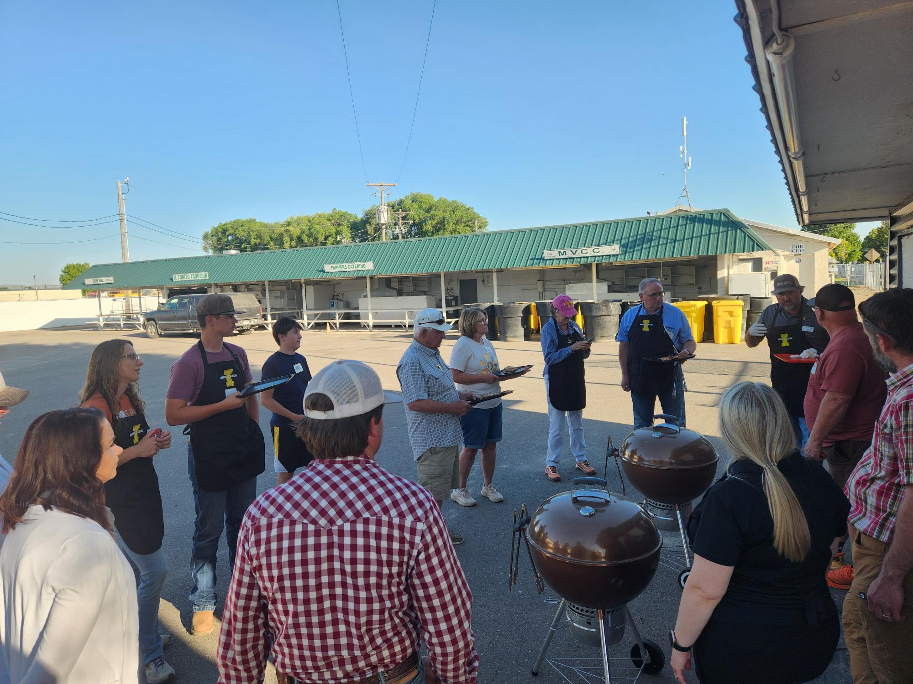

AT A GLANCE
UI Extension, Cassia County
208-878-9461 • 208-878-7862 (fax)
1459 Overland Ave., Rm. 4, Burley, ID 83318
Extension educators Brandon Brackenbury and Grace Wittman discussing the degrees of doneness with class participants.
A combined effort between agricultural and family and consumer sciences educators partnered to create a hands-on program to increase participants’ knowledge and confidence in grilling and smoking.

The Situation
As settlers moved west to new areas of the western U.S. cooking over an open flame was a way of life. Since that time grilling and smoking has evolved from being the way we prepared and preserved food to a popular cooking technique that has become a staple to many families’ summertime activities. The Covid 19 pandemic and the resulting inability to freely go out to one’s favorite restaurant has caused a resurgence in the popularity of grilling and smoking. Grilling and smoking was considered a summertime past time and has now evolved into a year-round way of preparing meals for family and friends. Because of this more people are cooking more meals at home, which increases the risk of foodborne illness. Unfortunately, the knowledge of safe food handling practices has not increased as the popularity of grilling has increased. This leads to a higher probability of people being at risk to encounter foodborne pathogens from improper food handling, cross contamination of ingredients, improper cooking techniques and food storage. The lack of knowledge of food safety results in approximately 48 million illnesses, 128,000 hospitalizations and 3,000 deaths in the U.S. according to Center for Disease Control. These incidences spike in the summer months and are a direct result of increased temperatures leading to increased bacterial growth and more outdoor food preparation like picnics and cookouts.
The second part of this program was aimed at helping participants increase their knowledge of other factors that contribute to a more palatable and higher quality product. To achieve this, we presented different cuts of meat (beef and pork), discussed cut selection (why certain cuts are more tender than others), United States Department of Agriculture quality grades, how degree of doneness affects palatability, the importance of resting meat, seasoning and brining, and why proper slicing techniques are important.

Our Response
In 2022, a Smoking and Grilling program was initiated between University of Idaho Extension educators in family and consumer sciences, and agricultural livestock to educate patrons on smoking and grilling techniques and food safety. This program was again offered in 2023 and 2025. Each of these programs consisted of two three-hour classes. Classes consisted of a lecture component, demonstration of meat preparation, different types of meat, cut selection, seasoning, food safety, degrees of doneness, USDA quality grades, brining and the differences between smoking and grilling, In each of the classes participants were able to prepare, season, and cook pork chops, tri-tip and steak using either method. During the second session participants were able to see a live demonstration of a brisket trimming and preparation followed by sampling of a cooked brisket. During these programs participants were also taught the process of smoking cheese and were able to sample smoked macaroni and cheese, cheesecake, funeral potatoes, snack mix, nuts and pepper jelly. In each of these programs’ participant feedback has and continues to allow adaptations to the program to better serve those in attendance. For instance, following the completion of the 2025 program, attendees showed interest in adding flat top grilling as well as vegetables and other types of meat.

Program Outcomes
In the three years of offering this program there have been 48 individuals participate, 25 females and 23 males. This program has helped participants increase their knowledge, skill, willingness to try new things, and interest in grilling and smoking. Combined efforts from educators in family and consumer sciences, and agricultural livestock sectors have created programming that has created an educational experience for participants to improve their awareness of food safety and techniques to create a more desirable product.
Upon completion of the program, all participants returned a voluntary evaluation survey. Information gathered from these focused on questions addressing their knowledge prior to and after concerning food safety, degrees of doneness, use of a thermometer while cooking, confidence in cooking and food safety.
Participants were asked a series of questions to describe their understanding of topics before and after attending the classes on the following: (Scale = one-five)
- Grill preparation and use increased from 2.75 to 3.62.
- Meat cut selection and differences knowledge went from 2.47-3.79.
- Willingness to use a thermometer and food safety concerns increased from 3.34-4.55.
- Understanding degrees of doneness and the potential outcomes improved from 3.02-4.38.
- Enhancing palatability went from 3.09-4.38.
Overall, participants’ confidence, knowledge and willingness to try new things while grilling and smoking increased significantly from their participation in this program. Many respondents also suggested their desire to learn about other types of meat to use in class such as fish, lamb and goat as well as vegetables in future classes. We are going to include the use of flat top griddles in future classes as well as expand the types of ingredients that we use.

For more information
Brandon Brackenbury, Extension Educator • University of Idaho Extension, Cassia County • 208-878-9461 • brandonb@uidaho.edu
Grace Wittman, Extension Educator • University of Idaho Extension, Cassia County • 208-878-9461 • gwittman@uidaho.edu
Joel Packham, Retired Extension Educator • University of Idaho Extension
48-25-bbrackenbury-grilling • 10/25

