Simulator-based solution for growing Idaho’s future logging workforce

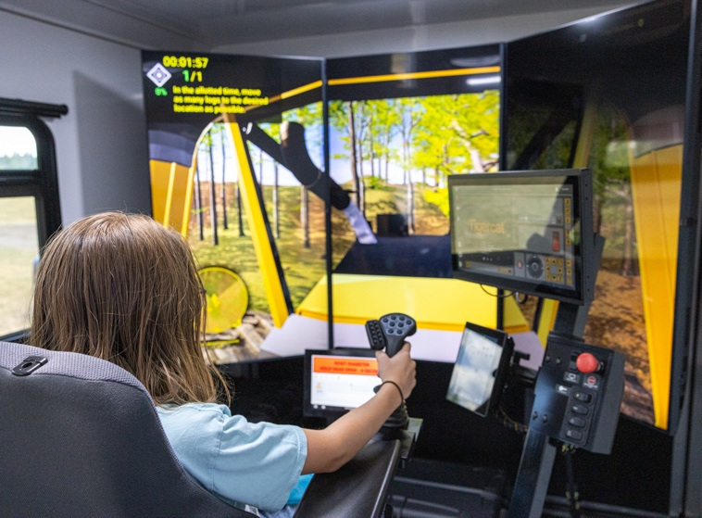

AT A GLANCE
University of Idaho Forest, Rangeland and Fire Sciences
208-874-2698
875 Perimeter Dr. MS 1133, Moscow, ID 83844-1133
Include a photo caption that identifies people and programs. Include photo credit if available. Two lines only.
Equipment simulators offer an innovative and impactful solution to support forest-focused education for Idahoans and engages the next generation workforce for the logging industry.

The Situation
Logging is a critical step in sustainable forest management and enables the successful management of our lands to support healthy, resilient forests. Despite the value brough to the state, especially in rural north Idaho communities, the logging industry faces persistent workforce shortages, recruitment challenges and an increasingly aging employee demographic. Even as increased mechanization and advanced technologies shape a safer, more sustainable and more efficient logging industry, steps must be taken to bolster workforce capacities and attract the next generation Idaho logger. This includes launching impactful, accessible and innovative educational and outreach-focused efforts targeting all Idahoans.

Our Response
As the logging industry has become increasingly technologically advanced, so have the tools available to support education, outreach and training. Logging equipment simulators are increasingly used across many industries to offer safe and accessible exposure to heavy equipment operation. Through successful grant awards and strong industry support, the University of Idaho College of Natural Resources and University of Idaho Extension have designed and mobilized two custom logging simulator trailers, bringing immersive, experiential learning resources to audiences throughout Idaho. These climate-controlled trailers house six cutting-edge equipment simulators and provide users of all ages a chance to operate contemporary logging equipment in simulated, reality-based scenarios while simultaneously being educated on the critical role of logging in sustainable forest management. Simulators from three equipment manufacturers (Tigercat, Jonh Deere, Caterpillar) offer five different pieces of simulated equipment.
These off-the-grid “mobile classrooms” maximize access to this powerful resource due to their ability to be brought anywhere roads allow. This removes travel and geographic barriers live, in-the-woods experiences might otherwise present. Proximity to active logging is no longer a limiting factor to audiences being exposed to the logging industry or being able to access introductory training and educational programming related to heavy equipment operation in this industry. This brings increased exposure to an industry needing to bolster workforce ranks and helps to shift public perceptions through increased educational outreach.

Program Outcomes
Since first launching in early 2024, the simulator trailers have served over 3,000 participants of all ages nearly 50 events throughout Idaho. Since November 2024, over 2,000 K-12 students, stakeholders and community members have sat in the seat of a logging equipment simulator and have been afforded a unique educational opportunity.
These simulator trailers have been operated at county fairs, logging conferences, grade school classes, career fairs, the Logger and Haulers Day at the Idaho State Capitol building, and for U.S. Representatives and their staff. In all, 17 Idaho school districts have benefitted from these educational resources in the last year.
Programming integrating logging equipment simulators focus on serving three key objectives:
- Career exploration and education for youth.
- Public education pertaining to technological advances in logging and sustainable forest management.
- Introductory training and professional development for the current and next generation logging workforces.

The Future
Programs for schools and publics events are currently being scheduled throughout 2026 as we continue to reach Idahoans statewide. Generous industry and grant support have allowed these simulator resources
to remain freely available for schools and community outreach events.
As interest in these logging simulation resources continues to expand, strategies for offering formalized training complimenting existing efforts at the University of Idaho, University of Idaho Experimental Forest and beyond are being explored. This new training pathway development is a critical step in providing the logging industry with the talent pipeline needed to meet future workforce needs.
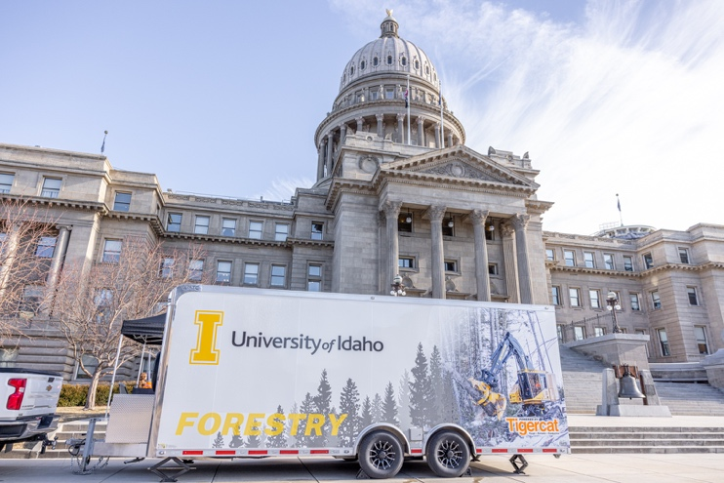
Logging simulator trailer in front of Idaho State Capitol for Loggers and Haulers Day with ALC-Idaho. Photo by Ryer Becker.

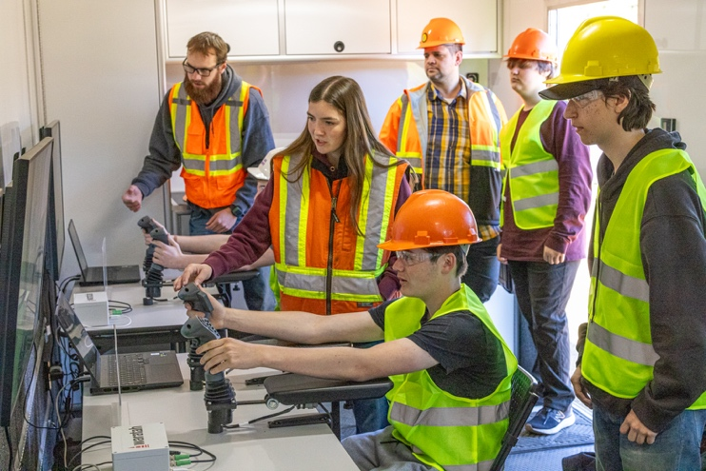
University of Idaho students teaching high schoolers basic equipment controls at career exploration event. Photo by Ryer Becker.

For more information
Ryer Becker, Forest Operations and Products Manufacturing Extension Specialist • University of Idaho Forest, Rangeland and Fire
Sciences • 208-874-2698 • rbecker@uidaho.edu
83-25-rbecker-logging-simulator • 12/25

