Rooted in the St. Joe event brings forest
education to rural Idaho community

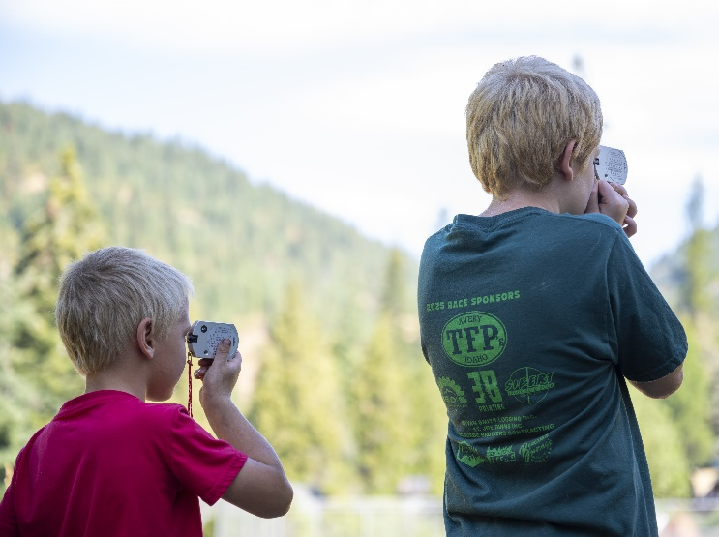

AT A GLANCE
University of Idaho Forest, Rangeland and Fire Sciences
208-874-2698
875 Perimeter Dr. MS 1133, Moscow, ID 83844-1133
Students determine tree heights with clinometers at forestry tools station. Photo by U of I Communications and Marketing.
In rural Idaho communities with deep timber industry roots like Calder, experiential learning for youth builds continued forest literacy and helps engage the future forestry workforce.

The Situation
The forest products industry has longstanding history in rural communities throughout Idaho. To this day, many of these communities still rely on this vital industry to provide jobs and economic stimulus to their residents. As youth grow up in these communities, many are exposed to the forest products industry due to jobs worked by family or simply by proximity.
However, providing hands-on, experiential learning opportunities provide a more wholistic and memorable exposure to an industry that is rooted so deeply in the places they live. This not only builds forest literacy, or an understanding of the many natural and operational factors driving the forest products supply chain, but also an exposure to career pathways and jobs they might otherwise be unaware of.
Partnerships with rural school districts in one effective means to bring these educational opportunities to life and directly to the target audience, the students.

Our Response
With a population of around 140, Calder is one of the smallest public schools in Idaho with just 15 students in grades K-8. Despite its size, Calder School values bringing immersive and experiential learning to its students. To enhance forest-based education and career exposure Calder’s youth, the University of Idaho Extension forestry team partnered with forest products industry stakeholders and school administrators to put on the Rooted in the St. Joe in August.
This event was focused on providing students of all ages with hands-on skills and knowledge building activities related to forestry, logging and forest products manufacturing. With these activities came opportunities to learn about the industry jobs related to these fields from industry professionals currently in these roles.
Four different stations capturing different skills related to the forest industry were set up for participants to rotate through. These stations included: logging equipment simulators; tree identification, tree planting and forestry hand tools for tree measurements.

Program Outcomes
In all, 44 youth and adults attended the Calder School Rooted in the St. Joe event. Despite only 15 kids attending the school, 24 attended the event as friends and family from the surrounding area came to participate in the day’s event. Six members from the UI
Extension forestry team; Ryer Becker, Randy Brooks, Chris Schnepf, Lauren King, Audra Cochran and
Maddie Goebel, led the four skills stations, bringing
together a broad range of forestry knowledge. Industry partners provided additional expertise and helped to make the rotations run smoothly.
By the end of the day, each student in attendance had the opportunity to rotate through each station and interact with both Extension and industry professionals. The day concluded with lunch provided by community members in the school’s cafetorium.
Parents spoke highly of the event and the experiences their children had throughout the day. As one parent stated, “The Rooted in the St. Joe event last week was fun and educational. All U of I persons there were very kind and attentive to the kids, with multiple activities to keep the kids engaged. The favorite among the kids was definitely the heavy equipment simulator.”
Another parent shared, “My two boys, ages 11 and six attended this event. It was wonderful! My 11 year old really blossomed and absorbed it all in and came home with so much to talk about. My 6 year old is very shy but all the educators were amazing with him and very patient and let him go at his own pace while encouraging him to try different things. This was a wonderful experience for my children. This gave them more knowledge of the beauty around them.”
This event helped highlight the impact hands-on learning experiences offer participants and the need to leverage these types of events in the future. Rural Idaho communities and their school districts greatly value these educational opportunities. For our timber towns, this rings especially true. University of Idaho Extension forestry team along with industry partners are
positioned to offer valuable learning opportunities to Idaho’s youth in rural and more urban areas by bringing these events to life.
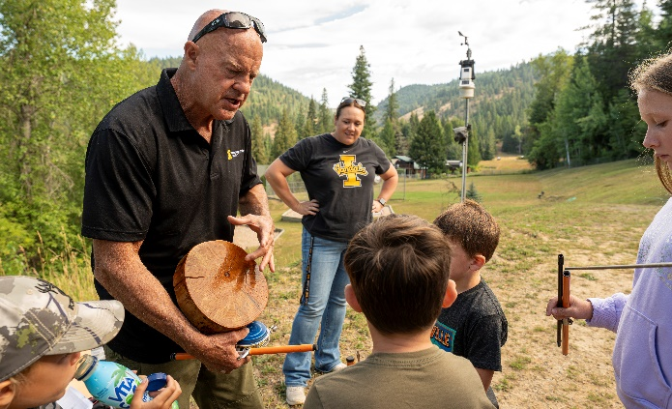
Extension forestry team explains trees growth and tools used to measure them. Photo by U of I Communications and Marketing.

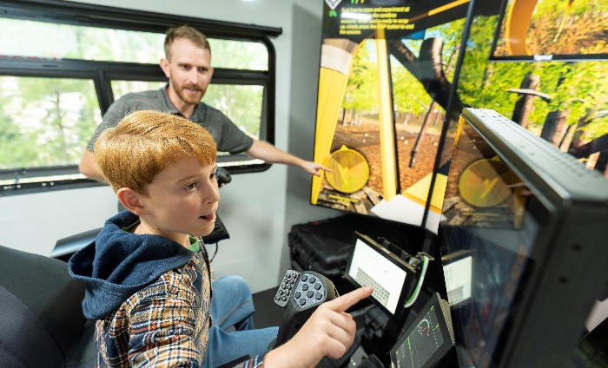
Students operated a skidder and feller buncher on the Tigercat simulators. Photo by U of I Communications and Marketing.

Cooperators and Co-Sponsors
This event was made possible by local timber industry and community sponsors and volunteers. Potlatch
Deltic provided volunteer expertise and seedlings to support the tree planting station.

For more information
Ryer Becker, Forest Operations and Products Manufacturing Extension Specialist • University of Idaho Forest, Rangeland and Fire
Sciences • 208-874-2698 • rbecker@uidaho.edu
Lauren King, Extension Educator • University of Idaho Extension, Benewah County • 208-245-2422 • laurenking@uidaho.edu
82-25-rbecker-forest-education • 12/25

