Meeting language needs: developing and delivering bilingual home canning resources

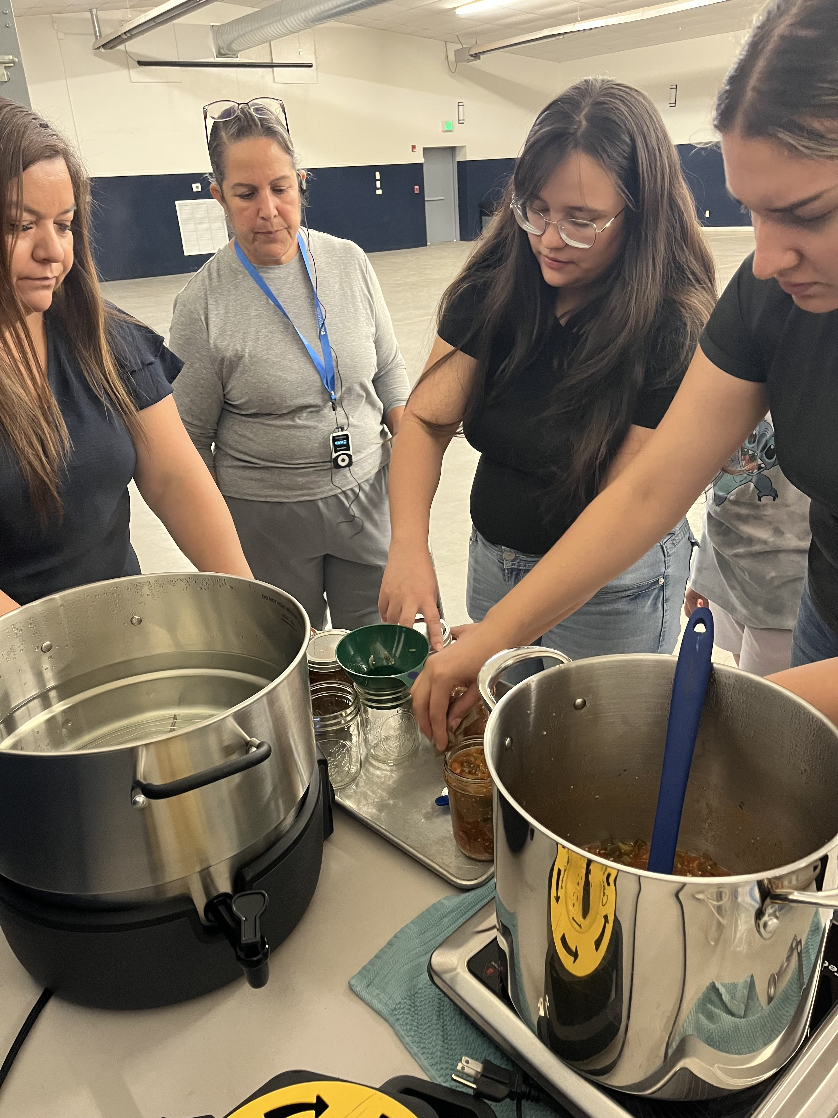

AT A GLANCE
UI Extension, Cassia County
208-878-9461 • 208-878-7862 (fax)
1459 Overland Ave., Rm. 4, Burley, ID 83318
Bilingual canning class participants preserving salsa in Jerome.
Recognizing a gap in accessible, research-based materials for Spanish speaking audiences, Extension educators developed and implemented bilingual boiling water canning classes in south central Idaho.

The Situation
Home canning has been a long-standing method of preserving foods for use throughout the year. The number of consumers participating in the activity has shifted up and down throughout history depending on society and family economic conditions. In the last few years, we have seen an increase in popularity for home preserving foods.
Between 2022-2024 family and consumer sciences University of Idaho Extension educators in south central Idaho worked with a local food bank to conduct drying, freezing and boiling water canning presentations to assist individuals who utilize the food bank to preserve products they get in bulk. Through these presentations UI Extension educators from Jerome, Cassia and Twin Falls counties determined there was a large need to conduct food preservation classes in a second language. Looking at the rate of Hispanics in the counites of Jerome, Cassia, Twin Falls and Minidoka it was determined that Spanish should be the second language.
A study was done in 2002 by the National Center for Home Food Preservation that indicated 48% of people get their canning information from family and friends. Other studies have found that when consumers follow recipes that include food safety practices, they are more likely to follow them. It is essential for Extension educators to provide the public with current, reliable and easily accessible resources for home food preservation and food safety. It is also important to provide accurate information in a language the consumer understands.

Our Response
Seeing a need for home canning classes for Spanish-speaking consumers Extension educators in south central Idaho decided to make bilingual food preservation classes a priority. It was determined to focus on boiling water canning followed by pressure canning if there was interest.
Once classes were determined, educators reviewed materials that were available in Spanish. There are a few Pacific Northwest publications that are available in both English and Spanish but the pressure canning document was not translated and there was not a document on boiling water canning. Working with a graduate student from Utah State University a document titled “Use, Care and Operation of Your Boiling Water Canner” was developed. This document was peer-reviewed by UI Extension educators and master food safety advisors. When it was complete it was translated into Spanish.
When UI Extension educators felt they had the documents to move forward with classes they held classes in Jerome, Twin Falls and Minidoka counties. A translator was hired to assist with recruitment of participants and then to translate during the classes. The first half of the classes consisted of verbal instruction on basic canning practices and the steps to using a boiling water canner. The second half of the class was hands-on applications where participants went through the canning process to preserve salsa. Each participant received the boiling water canning document, how to can tomatoes, salsa and fruits in both English and Spanish.

Program Outcomes
There were 45 people who attended the classes. Through their participation the UI Extension educa-
tors learned that the presentation needed to be simplified and focus on the major takeaways such as:
- What is safe to process in a boiling water canner
- What is not safe to process in a boiling water canner
- What are the steps to boiling water canning
- The importance of acidifying tomatoes
- The importance of making altitude adjustments
Participants in the first three classes indicated they wanted a class specific to jams and jellies. The UI Extension educators will conduct three more boiling water canning classes that focus on jams and jellies and adjust the presentation to emphasis the items listed above.

The Future
Pressure canning classes have been requested and will be conducted in the spring of 2026 after the publication “Use, Care and Operation of Your Pressure Canner” has been translated.
There are also plans to translate drying and freezing document so that there are pieces readily available for Spanish speaking consumers.
Cooperators and Co-Sponsors
- Maria “Celia” Villicana, translator

For more information
Grace Wittman, Extension Educator • University of Idaho Extension, Cassia County • 208-878-9461 • gwittman@uidaho.edu
Gretchen Manker, Extension Educator • University of Idaho Extension, Jerome County • 208-324-7578 • gretchenm@uidaho.edu
Siew Guan Lee, Extension Educator • University of Idaho Extension, Twin Falls County • 208-734-9590 • siewguanl@uidaho.edu
49-25-gwittman-bilingual-canning • 10/25

