Chainsaw basics workshop builds practical skills for safe operation and maintenance

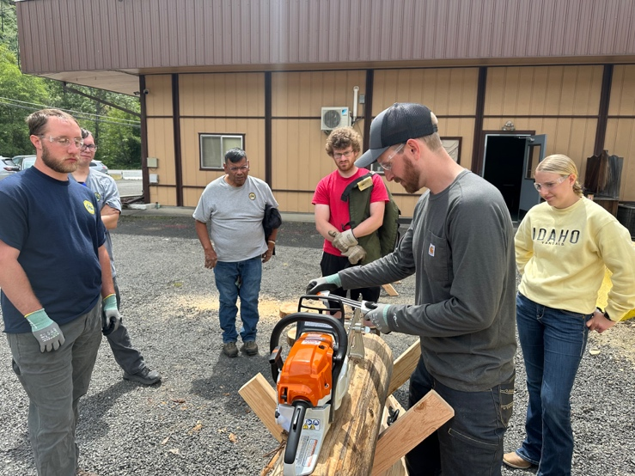

AT A GLANCE
University of Idaho Forest, Rangeland and Fire Sciences
208-874-2698
875 Perimeter Dr. MS 1133, Moscow, ID 83844-1133
Teaching proper chain sharpening procedures during Orofino workshop. Photo by Audra Cochran.
New statewide University of Idaho Extension program offers hands-on workshops focused on foundational skills and knowledge building related to chainsaw operation, safety and maintenance.

The Situation
According to the Centers for Disease Control, approximately 36,000 people are treated annually in hospitals nationwide due to chainsaw related injuries and accidents with roughly half those numbers requiring admission. Increased movement of individuals to Idaho’s rural communities and lack of existing training and
educational support in this space necessitates program development and delivery to support safe, effective chainsaw use for Idaho’s stakeholders.

Our Response
To address the need for practical, accessible and foundational skills building related to chainsaw operation, University of Idaho Extension developed a Chainsaw Basics workshop. The goal of this program was to equip participants with the applied knowledge and skills necessary to reduce the likelihood and occurrence of chainsaw-related accidents throughout Idaho.
With support from the Extension Innovative Project Award, equipment and supplies were acquired to develop and robust workshop offering participants with a combination of classroom instruction and hands-on skills building using a variety of chainsaw sizes and configurations.
Over the course of the 6.5 hour workshop, content covered included: proper personal protective equipment (PPE); chainsaw anatomy; saw startup procedures; basic scheduled maintenance; bar and chain service; building a safety mindset; and considerations for safe and effective chainsaw operation. Gas and battery-powered chainsaws were addressed as participants were given opportunities to operate both types of saws. All PPE and equipment were provided to workshop attendees.

Program Outcomes
As a new Extension program, identifying proper timing, participant numbers, and locations for effective workshop delivery offered learning opportunities and lessons learned will direct the scheduling and delivery of workshops moving forward. In the first year four workshops were delivered across three counties and one Tribal Reservation: Clearwater, Latah and Boundary counties and the Nez Perce (Nimiipuu) Reservation. Workshops were held in Moscow, Lapwai, Orofino, McCall and Bonners Ferry. Across the five locations, a total of 34 participants completed the workshop.
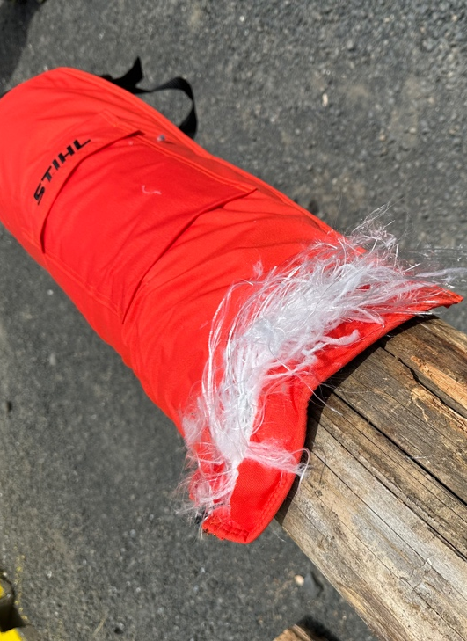
Live demonstration shows participants the function of chainsaw chap’s cut resistance for PPE. Photo by Audra Cochran.

Capping the workshop registration at 10 individuals benefitted the workshop and ensured each attendee had ample time to take advantage of the hands-on portion of the workshop. More pointed and focused attention was able to be given to each participant which helped support the overall success of the workshop.
Following the workshop, evaluations were given to assess the increase in knowledge associated with chainsaw safety, maintenance and basic operation. Additionally, participants were asked if they would implement or improved practices related to safe chainsaw operation, use of personal protective equipment (PPE) and proper chainsaw maintenance because of participating in the workshop.
Across all evaluations, nearly 100% of participants agreed or strongly agreed that their knowledge in three key areas; chainsaw maintenance, chainsaw safety and safe saw operations, increased because of participation in this workshop. Further, participants were asked if they believed the workshop would help them to implement or improve their practices related to safe chainsaw practices, proper use of PPE and proper saw maintenance. 96% of respondents said, “Yes” that they would implement or improve their practices related to safe chainsaw operation and proper PPE use. Regarding saw maintenance, 75% responded “Yes” while and additional 15% responded “Probably.”

The Future
With instructional content and resources in place,
future chainsaw workshops are already scheduled for the coming year in McCall and Boise. Chainsaw workshops will also be offered again in Moscow, Orofino and Lapwai and will likely be a program offered annually in these areas given continued interest. Additional stakeholders have inquired about hosting this workshop in their areas and we anticipate three to four
additional offerings in new locations in the next year.
Feedback from evaluations also indicated a strong interest in a more advanced chainsaw training as a follow-up to this Chainsaw Basics workshop at multiple locations. This option is actively being explored further and, if developed, would most likely be offered as an entirely field-based workshop.

Cooperators and Co-Sponsors
This workshop was made possible from support received through the Innovative Extension Project Award Program. Additional generous support through resource donations was also received from Stihl Northwest and Oregon Tool which we are grateful for.

For more information
Ryer Becker, Forest Operations and Products Manufacturing Extension Specialist • University of Idaho Forest, Rangeland and Fire
Sciences • 208-874-2698 • rbecker@uidaho.edu
84-25-rbecker-chainsaw-basics • 12/25

