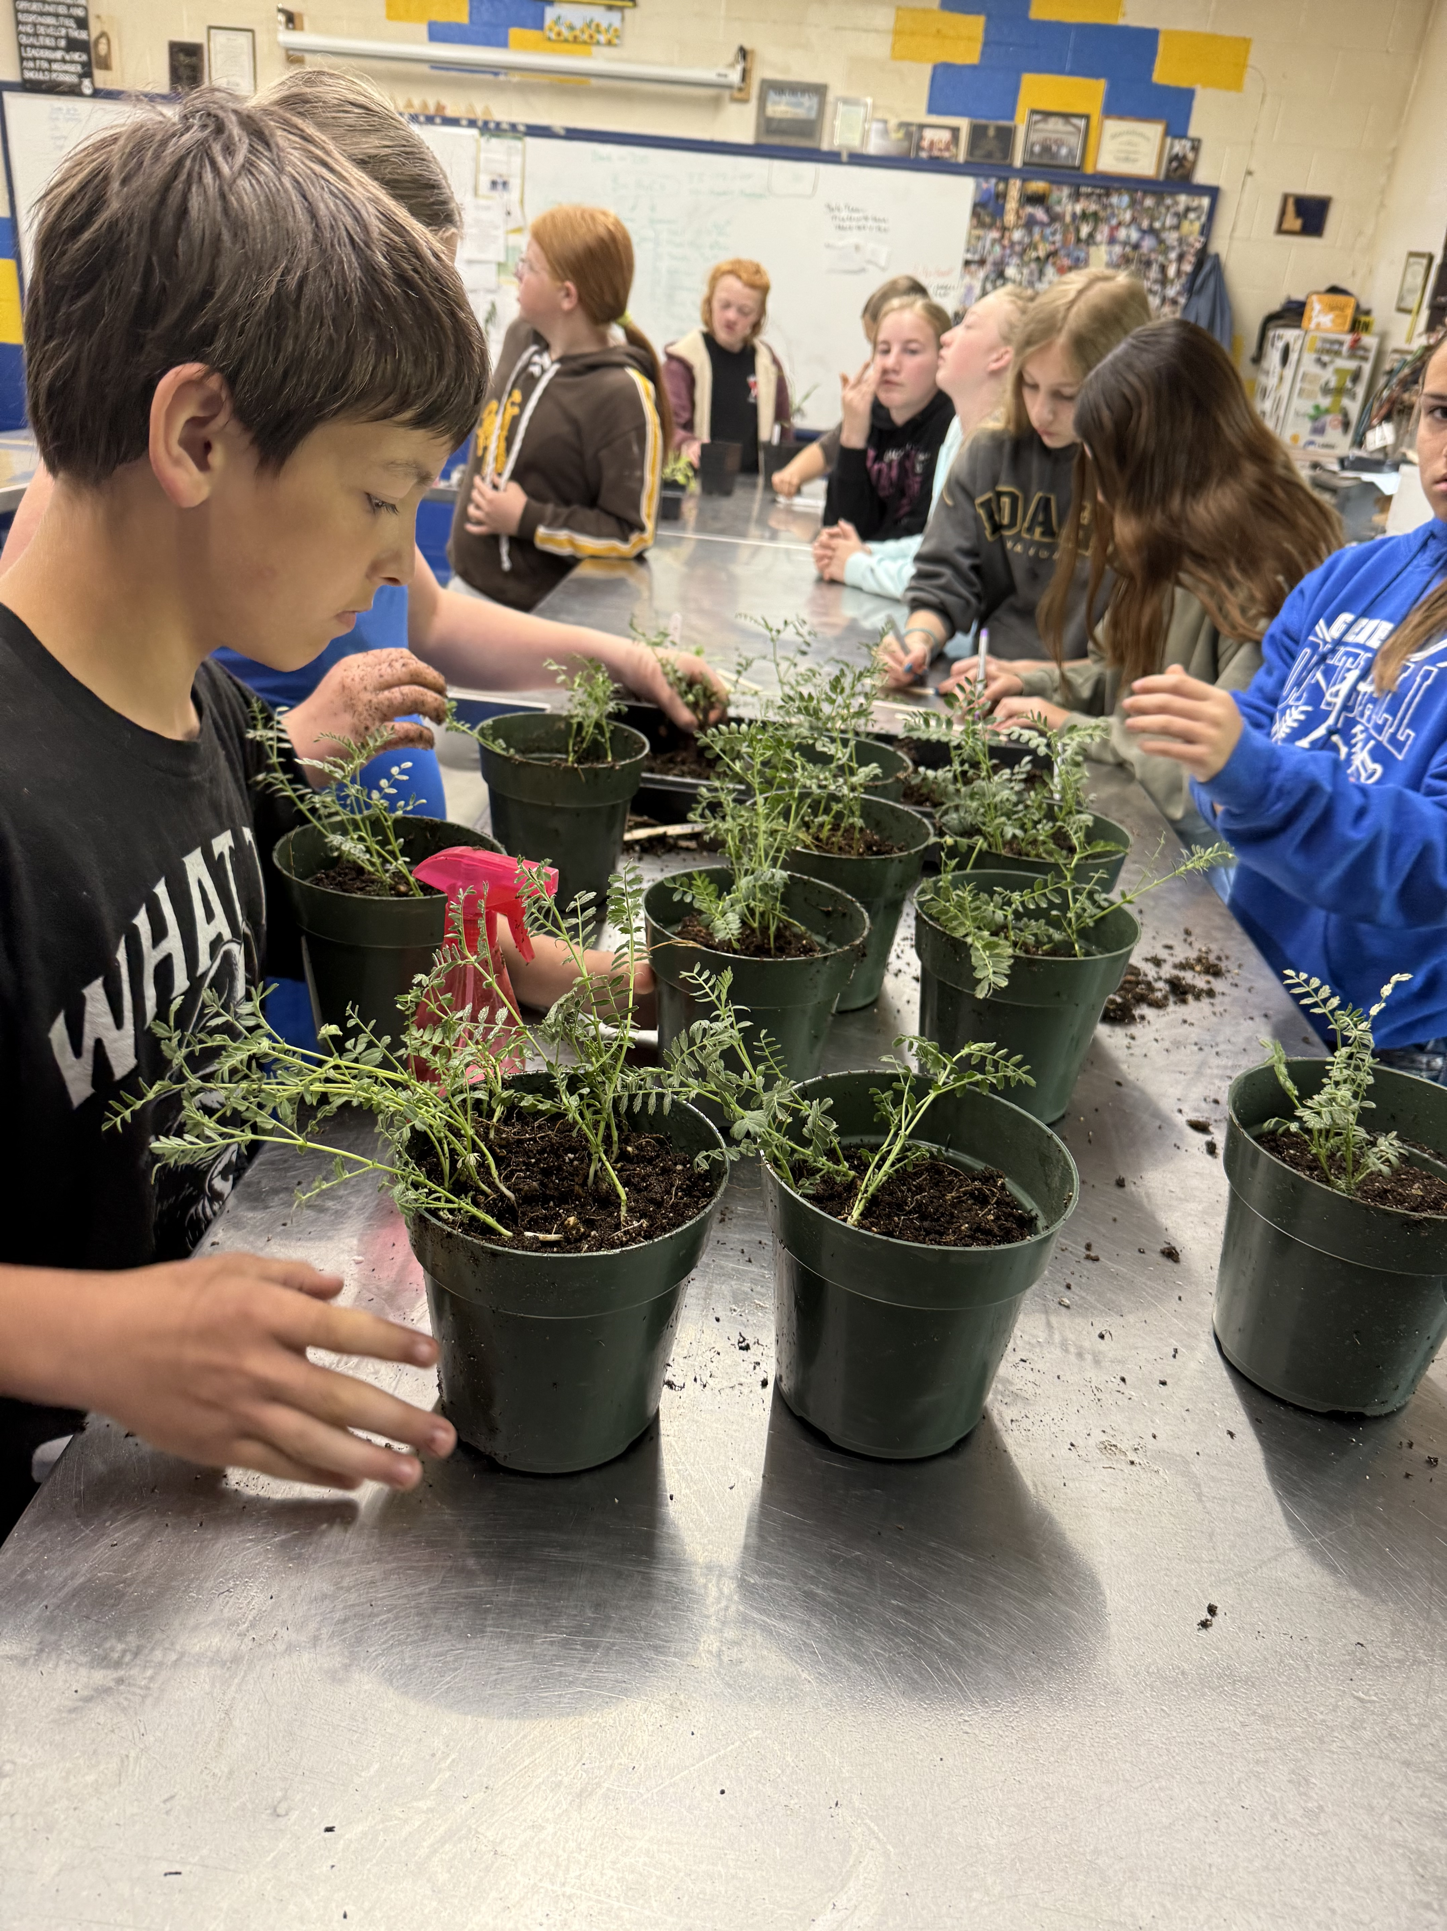
Farm-to-school program funded by USDA links Latah County students with local food


AT A GLANCE
UI Extension, Latah County
208-883-2267 • 208-882-8505 (fax)
200 South Almon St., Moscow, ID 83843
Genesee middle school students repot garbanzo bean plants in spring of 2025. Photo by Josh Nelson.
A farm-to-school initiative is improving access to healthy food through a fresh fruit snack, school gardens, classroom curriculum and kid-led farmers market activities.

The Situation
Latah County, an underserved rural area supported mainly by crops such as wheat, lentils, peas, oats and barley, faces significant disparities between food access and food consumption despite its extensive agricultural activities. In 2021, the per capita income in the county averaged around $31,000, with around 10% of the population being food insecure.
The USDA Food Access Research Atlas notes that three census tracts within the county are considered areas with low income and low access. Meanwhile, the county’s obesity rate has risen to close to 30%, with youth obesity rates mirroring a similar trend. The project addresses the community’s acute need to improve access to local food and provide agricultural education for youth to advance nutritional health.

Our Response
In 2024, University of Idaho Extension secured a grant from the USDA Food and Agriculture Service Learning Program (USDA-FASLP Award #2024-70026-42764) to increase access to local food in Troy and Genesee school districts. Titled “PEARS: Providing Educational Agriculture to Rural Schools,” the project focuses on providing experiential learning opportunities through school gardens to increase fruit, vegetable and legume consumption, foster business/leadership skills, and develop integrated educational curriculums to improve student’s food, garden and nutrition knowledge. All students in Tr0y and Genesee schools were provided a fresh fruit or vegetable snack for 12 weeks in each fall of 2024 and 2025 along with an educational worksheet. In spring 2025, students were also provided with soup kits featuring local ingredients for eight weeks.
Service learning — deliveries, educational handouts, summer teaching and farmers market activities have been implemented by nine undergraduate agriculture students with faculty supervision. Farmers market activities for kids hosted by college students have focused
on farm-to-table themes such as fruit and vegetable tasting, eating the rainbow, making ice cream, etc.
The long-term goal of the project is to bring together stakeholders from various parts of the food system to increase the consumption of local food, expand the capacity for food, garden and nutrition education within Troy and Genesee school districts, foster higher levels of community engagement between farms and schools and prepare students to be the next generation of leaders in food and agricultural sectors.
The project has included developing and evaluating integrated curriculum to reinforce food and nutrition-based learning throughout the school environment.

Program Outcomes
The project has had the following impacts for all enrolled students in Troy and Genesee schools:
- 661 students have had increased access to and consumption of local fruit, vegetables and legumes in elementary and secondary schools.
- Thirty (30) high school FFA (Future Farmers of America) students have improved business and leadership skills through a workshop on entrepreneurship, goal setting and effective communication.
- Middle school and high school youth in both school districts are gaining a working knowledge of how to keep track of plants grown and food produced through school garden activities, and keep track of seeds started, plants, food produced and seeds saved through in-home garden activities.
- Fifty (50) 4th graders in the two school districts will have a better understanding of food, gardening and nutrition, and have become confident in
explaining the knowledge to others through kid-led activities.
- 567 youth engaged in farmers markets activities in summer of 2025, hosted by college FFA and agriculture students, benefiting both groups.
- Sixty-five (65) students enrolled in the summer program in 2025 have gained food, gardening and nutrition knowledge, and connected with local producers.

The Future
As the project continues, additional activities will be implemented and impacts will continue:
- Fresh fruit snacks and soup kits will be delivered to all students in Troy and Genesee in 2026.
- A network of local farms interested in school food programs and a website containing all resources is being developed.
- Curriculum developed for FFA students will help them learn the skills to teach food and nutrition knowledge to younger students. This will help all students learn to make more informed dietary choices.
- FFA students will gain essential leadership skills by teaching elementary school students about growing plants and how to sell produce.
- College-level agriculture students will help implement school year and summer farm-to-school activities in 2026.

Cooperators and Co-Sponsors
Troy and Genesee school districts have partnered with faculty from University of Idaho Extension, College of Agricultural and Life Sciences’ Department of Agricultural Economics and Rural Sociology, and the College of Education.

For more information
Iris Mayes, Ph.D., Extension Educator • University of Idaho Extension, Latah County • 208-883-2267 • imayes@uidaho.edu
Jessie Van Buren, Ph.D., Extension Educator • University of Idaho Extension, Latah County • 208-883-2267 • jvanburen@uidaho.edu
Xiaoli Etienne, Ph.D., Professor, Department of Agricultural Economics and Rural Sociology • 208-885-0133 • xetienne@uidaho.edu
Taylor Raney, Ph.D., Associate Dean for Undergraduate Studies • College of Education, Health and Human Sciences • tcraney@uidaho.edu
Jue Wang, Ph.D., Assistant Professor of Literacy Studies • College of Education, Health and Human Sciences • juewang@uidaho.edu
47-25-imayes-local-food • 10/25

