K12 Residential Task Timeline

Thank you for partnering with us on a Program!
As we work to get you and your school ready for a week of Outdoor Science School, we are here to support you every step of the way. You’ll work with either Sacha or Dylan on specific tasks throughout the entire planning process. Feel free to email both of us—the right person will respond!

Hello! I’m Sacha. I’ll work with you on the Facilities Use Agreement, the enrollment process, billing, and scheduling your next program. Here’s what I’ll facilitate:
Many Months Before Program  - Receive confirmation letter  - Pay deposit  - Sign & return confirmation letter  A Few Months Before  - Facilities Use Agreement  - Enrollment — https://futurevandals.uidaho.edu/register/ws26  After Program  - Finalize invoice  - Pay balance  - Schedule next year | 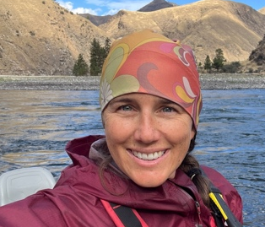  Sacha Jackson  Business Operations and Enrollment  sachaj@uidaho.edu

Hello! I’m Dylan. I’ll work with you to ensure your program runs smoothly and meets your needs. You’ll start hearing from me about 90 days before your program begins. Here’s what I’ll facilitate:
3 Months Before  - The Pre-Program Questionnaire  - Recruit Chaperones — we suggest 1 adult per bunkhouse unit and 1-2 per dorm space  - Share relevant information from the MOSS Program Resources! folder – i.e., What to Bring, Role of Teachers & Chaperones, etc.  2 Months Before - Complete Group List  1 Week Before - pre-program Zoom or phone call  Arrive @1p MT on the first day  Depart @10a MT on the last day | 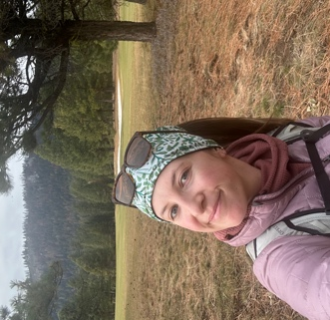  Dylan Reeves  K12 Program Coordinator  dmporter@uidaho.edu
We look forward to our partnership on your program. Please reach out with questions anytime.
Have a wonderful day!

