Extension partners with St. Luke’s to
provide 4-H programs at Boys & Girls Clubs

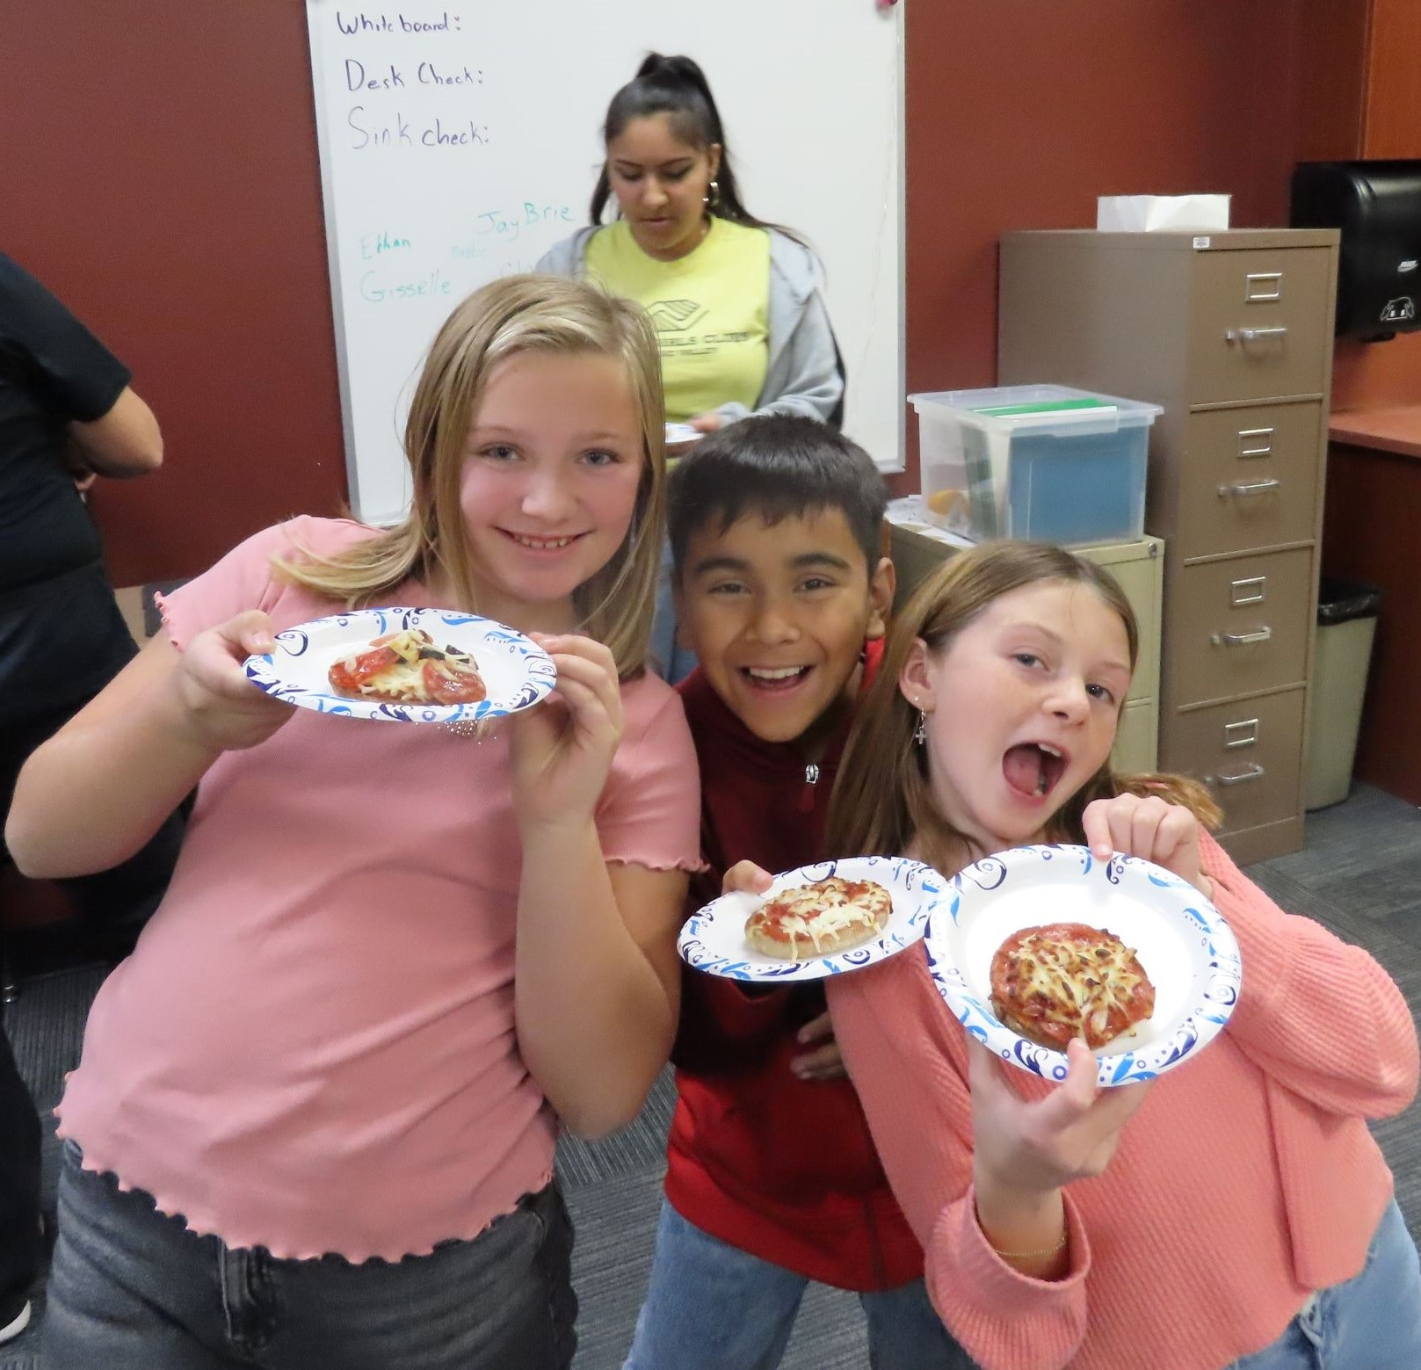

AT A GLANCE
UI Extension, Jerome County
208-324-7578
600 2nd Ave W Jerome, ID 83338
Members of The Dino’s 4H Club displaying their whole grain air fried pizzas.
University of Idaho Extension and St. Luke’s Health System partner with the Boys & Girls Clubs of Magic Valley to provide youth in Jerome County with 4-H programs that develop life skills.

The Situation
The benefits to youth that participate in positive youth development programs like University of Idaho Extension 4-H Youth Development and Boys & Girls Clubs are well documented. Youth that participate in programs that offer opportunities to build strengths, provide opportunities for growth and offer a sense of belonging have better academic outcomes. Specifically, research indicates that youth in 4-H tend to perform better in school, showing higher grades, have greater engagement, continue to postsecondary education and graduate from college. They are also more likely to have the goal of being a leader and participating in community service.

Our Response
To promote positive youth development in Jerome County, UI Extension 4-H Youth Development partnered with St. Lukes’s to provide 4-H programs to members of the Jerome Boys & Girls Clubs. St. Lukes funding supported three separate 4-H programs at the Jerome Boys & Girls Clubs from fall of 2024 through summer of 2025. Additional funding from UI Extension at the state and district level supported a 4-H summer intern to provide programs.
4-H Special Interest (SPIN) Club — An Extension educator and 4-H coordinator in Jerome County implemented a 4-H Special Interest (SPIN) Club for 4th and 5th grade Boys & Girls Clubs after school members. The students participated in all aspects of belonging to and running a 4-H club. They followed parliamentary procedure to hold club meetings, elect officers, establish a club name (The Dino’s 4-H Club), vote on club activities, complete a community service project and display their projects at the 2025 Jerome County Fair. For their community service project, the Dino’s designed cards and sent them to soldiers serving in the National Guard. To promote healthy living and learn new skills, they prepared air fried whole wheat pizzas, tooled leather craft bracelets, built Wiggle Bots and designed their display for the Jerome County Fair.
4-H STEAM activities — The 4-H coordinator and summer intern introduced youth to science, technology, engineering, art and math (STEAM) activities for K-5th grade club members during after school and summer programming. These STEAM activities included making snow, sprouting chia pets, decorating cookies, making butter and doing an acrylic pour.
4-H Cooking Club — The Extension educator and 4-H summer intern worked with 4th and 5th grade youth on developing basic cooking skills through a weekly
4-H Cooking Club. The program provided hands-on skill-based lessons in nutrition, food preparation and food safety. The cooking club members prepared healthy recipes, learned basic cooking skills and tried new foods. The recipes this summer included colorful fruit and cheese kabobs, hearty whole wheat pancakes, slushy mango smoothies and zesty salsa. The youth also practiced basic sewing skills by learning how to sew on a button and creating a hanging oven mitt hand towel. The members enjoyed tea and cookies during their sewing experience. They also created a custom placemat to use all summer and set the table each week before eating. Each youth participant received a colorful apron and cooking utensils to take home at the end of the summer.

Program Outcomes
Overall, the collaboration of University of Idaho Extension, St. Lukes Health Systems and the Boys & Girls Clubs of Magic Valley provided life skill building 4-H programs to 44 Boys & Girls Clubs youth during the 2024-2025 school year with after school 4-H STEAM programs (once a month) and an afterschool 4-H Special Interest (SPIN) Club (three times a month). The Dino’s 4-H Club had 12 4th and 5th grade members, five boys and seven girls. This community collaboration also provided 72 Jerome Boys & Girls Clubs youth during the 2025 summer programming with weekly (K-second grade on Tuesdays/third-fifth grades on Thursdays) 4-H STEAM programs for 46 youth, 20 boys and 26 girls and weekly (third-fifth grades on Wednesdays) 4-H Cooking Club for 26 youth, 12 boys and eight girls.

The Future
Due to the generous continued financial support from St. Lukes, 4-H activities are underway at two locations of Jerome Boys & Girls Clubs programs for the 2025-2026 academic year and summer sessions. This year’s programming will focus on healthy eating with the introduction of nutrition topics, new foods, basic cooking skills and a physical activity component for kindergarten through fifth grade youth.





For more information
Gretchen Manker, Extension Educator • University of Idaho Extension, Jerome County • 208-324-7578 • gretchenm@uidaho.edu
Katlyn Scheer, 4-H Coordinator • University of Idaho Extension, Jerome County • 208-324-7578 • katlynts@uidaho.edu
46-25-gmanker-4h-clubs • 10/25

